GDP Presentation 2
Slide 1
Malware detection based on repetition of the trendy keyword:
  - Analyse the content of the given URL (Crawling)
  - Check content of each hyperlink on the webpage
  - Consider frequently of reappearances of trendy keyword
  - Used the result of this algorithm for URL classification

Slide 2
URL Classification

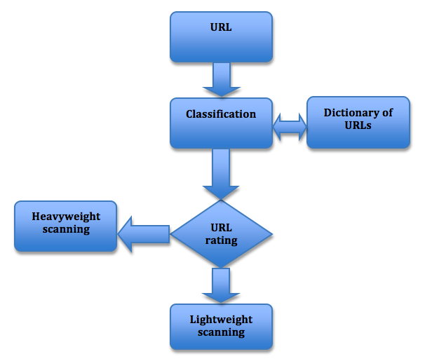

Slide 3
Two machine-learning methods applied in classification algorithm:
- Levenshtein distance
  - String metric for measuring the difference between two sequences
  - Minimum number of edits needed to transform one string into the other
- K-mean Clustering
  - Data mining
  - Partition n observations into k clusters
  - Applicable on large amount of data

